

**Financial Implications of Russia-Ukraine War on Pakistan**

**The Good, the Bad and the Tricky.**

**Report By: Bilal Ahmed Khan (20K-0183, Sec:A)**

Contents

1. Introduction: 3

2. The war's impact on Global Oil Markets: 4

3. What’s in it for Pakistan: 5

4. When elephants fight it is the grass that suffers: 6

5. Pakistani State’s narrative thus far: 7

# 

# 1. Introduction:

Ukraine (part of the former Soviet Union) had been getting close to the Western Military Alliance, NATO after she lost Crimea to Ukraine during the 2014 war between Russia and Ukraine. Russia still not fully recovered from the wounds of the COLD WAR (1947-1991) doesn't like American-backed forces near its borders. For a long time America has been closing in on Russia from the European sides of its border and Ukraine joining the NATO alliance would've allowed NATO front door access to the West in case of an all-out war.

Things had been escalating between the two countries since the start of 2022 with on and off border clashes. Global think tanks and news outlets had been predicting a full-scale war between Ukraine and Russia for quite some time now, it all came true when Russia invaded Ukraine on 24th Feb 2022 through Belarus from the North and through Crimea (which Russia had already annexed from Ukraine in 2014).

Russian President Putin said that his goal was to "demilitarise and de-Nazify Ukraine", to protect people subjected to what he called eight years of bullying and genocide by Ukraine’s government.

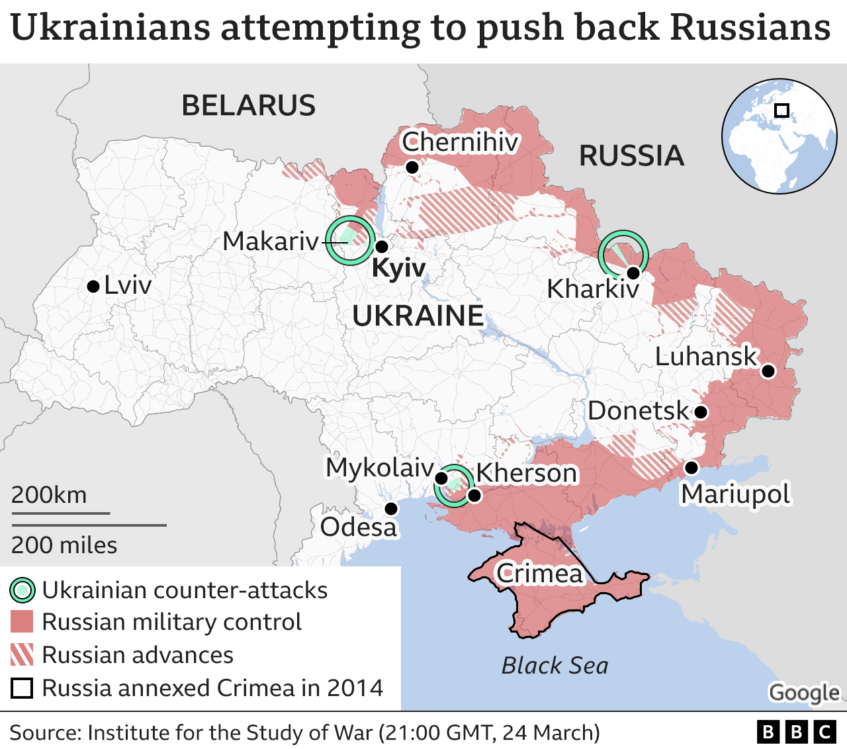

Figure A map of the Ukraine Russia War

# At the time of writing this report, it has been 32 days since Russia invaded Ukraine and till now there is no sign of a ceasefire despite the effort of Turkey and other countries to mediate the situation between Russia and Ukraine.

# 2. The war's impact on Global Oil Markets:

The Global Supply chains were already suffering from the shocks of Covid-19, in such a situation the Russia Ukraine war added fuel to the fire (pun intended). Russia is the 2nd largest producer of oil hurting the already bad global markets. The prices of Oil (per barrel) went above $100 for the first time since 2014 reaching up to $123.70 at spot price.

Pakistan is a net exporter of Oil and the sharp increase in oil prices is bound to hurt the already struggling economy. With the depreciating value of PKR, the increase in oil prices will hurt the Pakistani population even more. The current Govt. has been facing severe criticism from all segments of Pakistani society due to the increasing Gasoline Prices since the petrol prices soared up to PKR-159. Although the Govt. slashed the prices of petrol by Rs.10/- reducing the per liter cost of petrol to PKR-149. The PM also announced that the petrol prices shall remain the same till the announcement of the budget for the next fiscal year in June 2022

The soaring prices of Oil pressured the already struggling economies that were struggling to recover from the devastations of Covid. Pakistan was no different, with an already existing problem of balancing the current account deficit the ever-increasing prices of fuel made things even worse. With a fall in remittances by around $450 million (a 15 percent month-on-month decline) in Jan 2022 due to the easing travel restrictions and increasing Oil Prices, Pakistan’s current account gap soared up to 2.56 billion dollars.

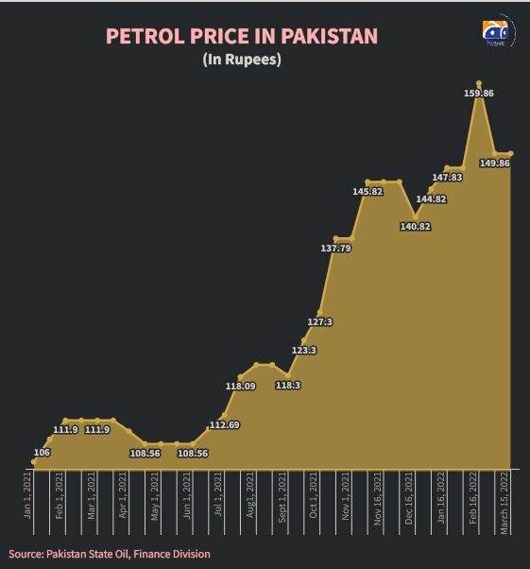

# 3. What’s in it for Pakistan:

The bilateral ties between Islamabad and Moscow suffered some heavy blows when Pakistan aligned itself with the U.S. and for the role, Pakistan played during the Afgan Jihad and the failure of the USSR in the Afghan War.

With the global realignment of states happening, Pakistan is looking to distance itself from the ‘US Camp’ and trying to diversify its bilateral and export ties with the countries primarily in Central Asia, Russia, and China. Pakistani Prime Minister Imran Khan’s latest visit to Moscow also intended to boost energy and economic cooperation between the two sides and further the talks on the multibillion-dollar Pakistan Stream Gas Pipeline project. With Pakistan’s rapidly depleting gas reserves the Govt. is inclined to explore alternate sources for fulfilling its domestic gas needs. The PSGP Project will prove to be a breath of fresh air for the Pakistani public who have to suffer from long hours of gas load shedding during winters due to a sharp increase in gas demand.

With Economic Sanctions lining up on Russia Pakistan can cash in its improving bilateral ties and try to cut a deal at discounted rates. A couple of commodity trading firms — such as Glencore and Vitol — were offering discounts of $30 and $25 per barrel respectively two weeks ago for the Urals blend, Ellen Wald, president of Transversal Consulting, told CNBC. Previously India used to import only about 2-3 percent from Russia, although lately a ‘significant uptick’ of Russian oil bound for India has been observed. Since March, five cargoes of Russian Oil, or about 6 million barrels have been loaded and bound for India. Pakistan can also devise a strategy to buy Russian Crude Oil at discounted rates and keep its increasing Current account deficit in check.

# 4. When elephants fight it is the grass that suffers:

The presence of the Pakistani PM while Russia launched an attack on Ukraine was not received well by the ‘West in Particular’.

The foreign envoys of various 22 European nations (including Germany, France, and other prominent members of the EU) wrote a joint letter to Pakistan and urged Pakistan to ‘condemn the Russian invasion of Ukraine’ during the emergency UNGA session in Feb 25, 2022.

Pakistani Prime Minister responded to the letter by saying that Pakistan was not their “slave”.

"What do you think of us? Are we your slaves ... that whatever you say, we will do?" Khan said while addressing a political rally.

The Pakistani PM also pointed out the hypocrisy of EU countries on their silence upon India’s actions in Kashmir, a disputed territory over which both countries have fought 2 wars.

Imran Khan further said that Pakistan has suffered because it had supported the Western NATO alliance in Afghanistan, and instead of gratitude faced criticism.

"We are friends with Russia, and we are also friends with America; we are friends with China and with Europe; we are not in any camp," Khan added, saying Pakistan would remain "neutral" and work with those trying to end the war in Ukraine.

The Pakistani Foreign Office spokesperson also issued a statement which said that the letter was “not usual diplomatic practice” for diplomatic missions to make their letter public and that it was made clear to the EU representatives.

On 4th March, The United States State Dept. stated that it had “informed” Pakistan that the war in Ukraine could have both regional and global consequences.

Pakistan’s UN Ambassador Munir Akram says that Islamabad is not only aware of the consequences of its actions, but also “supports all efforts” to restore peace in Ukraine.

# 5. Pakistani State’s narrative thus far:

Thus far Pakistani state has maintained a fairly “neutral“ stance on the conflict. The Pakistani Prime Minister urged “dialogue and diplomacy” to resolve Russia's tensions with Ukraine, saying he “regretted” that a military conflict could not be averted between the two neighboring countries.

This statement was issued after a 3 hr long meeting with Russian President Vladimir Putin at the Kremlin. Since the Pakistani Premiere's visit to Moscow, Pakistan has maintained a stance of being neutral and facilitating dialogue between the two countries.

Pakistan’s UN Ambassador Munir Akram said, “We are advocating a ceasefire and negotiations. If we had joined the Ukraine resolution, we would have no political space for diplomacy with the two sides”.